Porrentruy, 25 February 2026
PRESS RELEASE

A new species named in honor of Charles Aznavour
A team of researchers from JURASSICA (Porrentruy, Switzerland) has announced the discovery of a new fossil species of hyrax in Armenia. This exceptional find was made possible through fieldwork conducted in close collaboration with the Institute of Geological Sciences of the National Academy of Sciences of Armenia. The study sheds light on what this enigmatic mammal looked like more than 3 million years ago and on the past dispersal of mammals between Africa and Eurasia throughout history. This new species has been named Armenohyrax aznavouriani in honor of Charles Aznavour, a singer and ambassador of Armenian origin, symbolizing the cultural link between Armenia, the Francophone world, and Switzerland, where he lived –reflecting the international cooperation behind the discovery.
This international scientific cooperation led to the discovery of a new genus and species of fossil mammal, Armenohyrax aznavouriani. The research teams worked at the Jradzor paleontological site in Armenia, which represents one of the richest Pliocene sites in Eurasia (between 4 and 3 million years ago). During this time, volcanic flows rapidly buried and literally “froze” (like in Pompey) the local fauna. Consequently, more than 50 species of vertebrate fossils have been identified at this site, providing a rare and unique window into an ancient ecosystem.
The exceptional fossil discovery of Armenohyrax represents a remarkably well-preserved skull dated to 3.3 million years ago. Hyraxes are small mammals resemble large rodents today restricted to Africa and the Middle East. Although they resemble large-sized rodents, the group (including Armenohyrax) belongs to an African lineage that is more closely related to elephants and manatees (sea cows) than to rodents.
This new species contributes valuable data on Pliocene biodiversity of the South Caucasus. It helps scientists in understanding how these animals dispersed between Africa and Eurasia and how the ecosystems of the South Caucasus have changed through time. The study also presents the first formal phylogenetic reconstruction of the fossil family Pliohyracidae within Hyracoidea and confirms Jradzor as a key reference site in western Asia for Pliocene mammals. The results suggest that western and southern central Asia played a pivotal role in the evolution of this now rare group.
Damien Becker, Director of JURASSICA, explains: “Naming this species after Aznavour was an obvious choice. He embodies the cultural ties between Armenia and Switzerland, just as this discovery stems from the close cooperation between our teams. It is a way to honor his legacy and underline the human and international dimension of science.”
Teams from both institutions participated in the fieldwork. The preparation and restoration of the specimen, its scientific analysis, and publication of the results were led by the JURASSICA team. Widely recognized for its paleontological research, the Jura-based institution continues to deliver high-level fundamental science and contribute to international advances in understanding the evolutionary history of life.
Publication :
Becker D., Lefebvre R., Saulnier Masson R., Vasilyan D. (2026). Swiss Journal of Palaeontology. A new genus and species of Pliohyracidae (Hyracoidea, Mammalia) from the Pliocene of Jradzor, Armenia. Swiss Journal of Palaeontology. DOI : 10.3897/sjp.145.181371
Contacts :
Dr. Damien Becker, Director of JURASSICA
damien.becker@jurassica.ch, 032 420 92 10

Dr. Davit Vasilyan, Lecturer & Research Scientist, JURASSICA,
davit.vasilyan@jurassica.ch, 032 420 92 11

Link : https://sjp.pensoft.net/article/181371/

Photos :
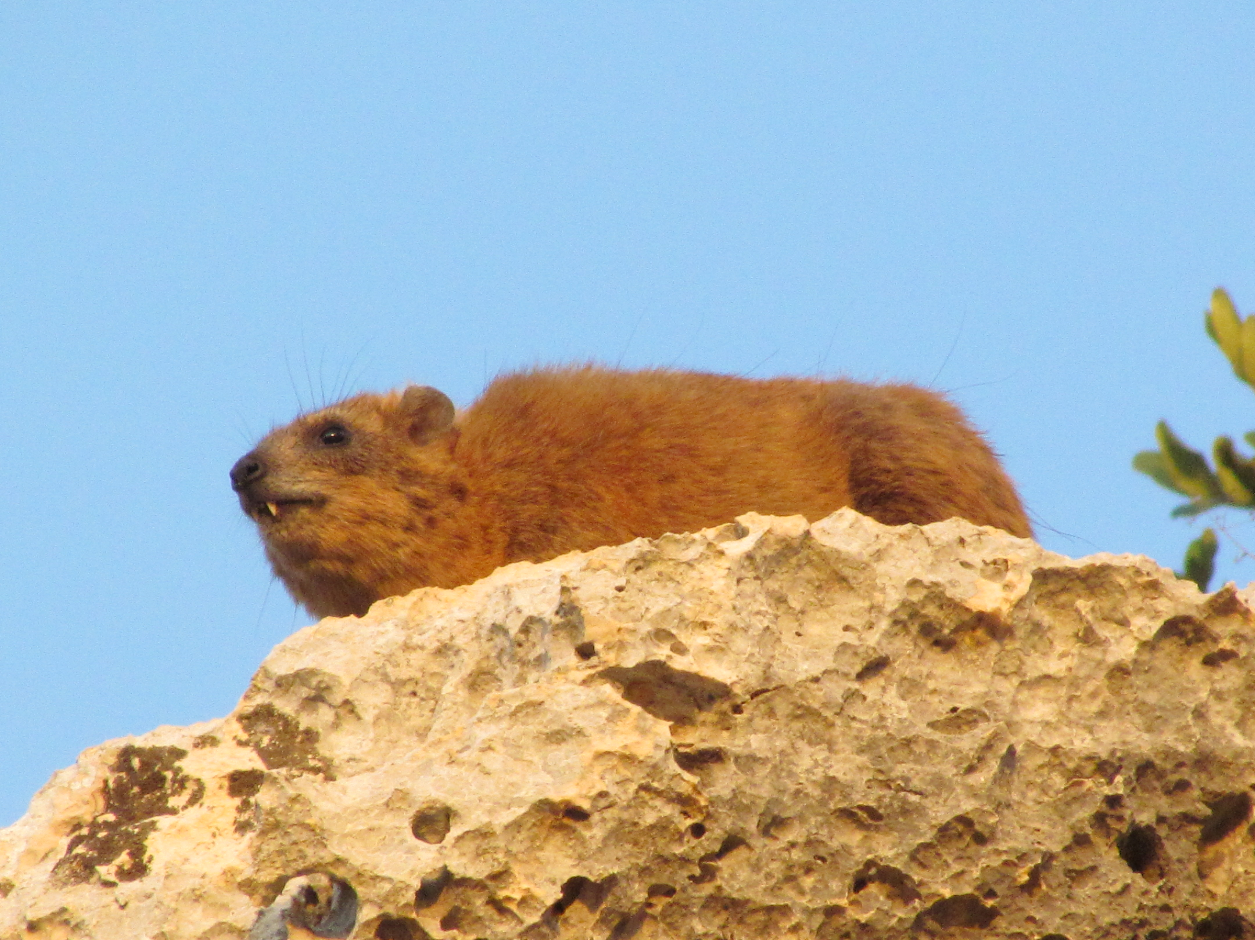
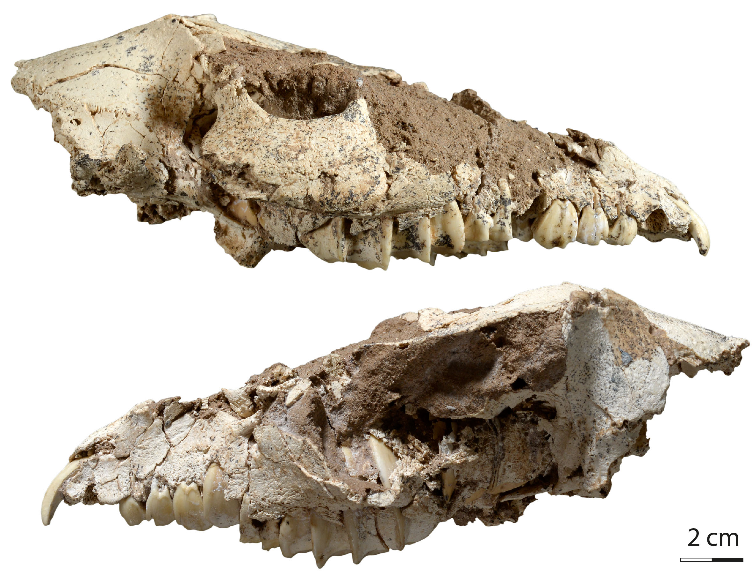
Cape hyrax Procavia capensis (a recent hyrax species) in its natural habitat, from the Near East. © Davit Vasilyan

Skull of Armenohyrax aznavouriani, in lateral views. © JURASSICA

